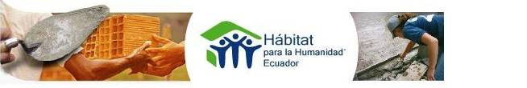

TEAM MEMBER´S
M A N U A L

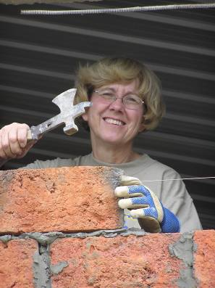

E C U A D OR
November 2007

Table of Contents

WELCOME LETTER 4

COUNTRY PORTRAIT 5

MONEY MATTERS 6

HABITAT ECUADOR 8

ARRIVING IN ECUADOR 10

THE HOUSE GOES UP 13

YOUR STAY IN ECUADOR 15

THE FINE PRINT 19

CONTACT INFORMATION 20

A FEW WORDS…. 21

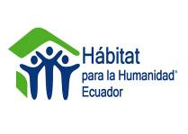
WELCOME LETTER

Dear Team Member,

On behalf of the staff of Habitat for Humanity Ecuador, the more than 600 homeowner families and the 100 local volunteers in country, I want to be the first to welcome you to Ecuador! We are excited that you have chosen to participate in the struggle to eliminate inadequate housing in Ecuador and we look forward to sharing that passion with you and your team.

Habitat for Humanity Ecuador is committed to providing participants with a well-organized and rewarding short-term mission trip. The quality of the experience is directly related to the leadership provided by the team leader, the Habitat coordinator, the host affiliate, and the attitudes of the team members themselves.

Thanks to people like you, Habitat for Humanity International has built and renovated more than 200,000 homes for people around the world. In Ecuador more than 450 homes have been built which means we have changed the lives of more than 450 families!!!!!

I promise to do everything in my power to make your experience as enriching (and hassle-free!) as possible. If you have any questions or concerns, please contact your team leader and we will answer them together. It is my great pleasure to welcome you to the Habitat for Humanity Ecuador community!

Sincerely,
Carley Therese Simpson de Dávila
National GV Coordinator
Habitat for Humanity Ecuador

A COUNTRY PORTRAIT

INTRODUCTION
The smallest country in the rugged Andean highlands, Ecuador has an array of vibrant indigenous cultures, well-preserved colonial architecture, otherworldly volcanic landscapes and dense rainforest. All of these are located in a nation no bigger than the US state of Nevada, with a total area somewhere between the United Kingdom and Italy.
Touch down in its picture-perfect capital, Quito, and you are no more than a day's drive from a slog through the Amazonian jungle, a snow-swept ascent of an active volcano, a sociable haggle with indigenous artesanos or a coconut juice on a tropical beach.
If you squint your eyes at a map of the region, Ecuador looks something like a grinning skull, gazing across the Pacific at its lone 'overseas' holdings, the blissfully distant Galapagos Islands. Owned by Ecuador since 1832, the far-flung islands are lauded as one of the world's greatest natural history treasures, their unique diversity of plant and animal life provide a living textbook for ecologists and tourists alike. It´s a bit pricy to go to the Galapagos, but the rare beauty and friendly animals make it worth every penny
COUNTRY FACTS
Full country name: Republic of Ecuador
Area: 283,520 sq km
Population: 13.44 million
People: 40% mestizo, 40% Indian, 15% Spanish descent, 5% African descent
Language: Spanish, Quechua
Religion: Over 90% Roman Catholic with a growing minority of other Christian denominations. There is also a high prevalence of indigenous beliefs which usually present themselves as syncretism, combining indigenous and Roman Catholic beliefs.
Government: Democracy
Head of State: President Rafael Correa
GDP: US $41,700,000,000
GDP per capita: US $3,100
Inflation: 8.2%
Major Industries: Oil, bananas, shrimp, fish, coffee, flowers, textiles, metal work, paper products, wood products, chemicals, plastics, fishing, lumber.
Major Trading Partners: US, Latin America, EU, Asia, Caribbean
Currency: US Dollar
* For more information on Ecuador history, culture, and other topics, visit Lonely Planet’s Ecuador profile on line at http://www.lonelyplanet.com or www.vivecuador.com.

MONEY MATTERS

GLOBAL VILLAGE DONATION: Sponsoring the house you build

We ask work teams to contribute toward the house-building effort. Every team member is requested to donate $450, all of which is tax deductible. Your donation directly benefits the affiliate with which you will be working, minus a small Habitat for Humanity International (HFHI) administration fee. This donation is handled through HFHI headquarters in Americus, GA. Please contact your team leader concerning all matters regarding the donation and international insurance matters.

We understand this amount may be a challenge and Habitat is ready to assist in any fundraising efforts. We highly encourage each brigade member to be imaginative and get involved early on in the planning stages of the trip. Car washes, bake sales, and other such events form brigade camaraderie and spread news of Habitat and our cause. If desired, we can provide before/after photos, family testimonies, and other fundraising materials.

YOUR DAILY FEE: Habitat for Humanity–Ecuador, National Office

Habitat Ecuador requests a fee of $35/person/day during your stay with us. These funds should be submitted directly to your team leader, who will send them to the HFHI headquarters.

This daily fee includes:
- Transportation to and from the airport, or the bus terminal closest to the affiliate
- Daily transportation to the work site
- Orientation materials
- Breakfast, lunch, and dinner
- Purified water and two snacks on site daily
- Welcome snack
- Going away party and participation certificate
- Administration costs for six months of planning with full time coordinator (telephone, fax, internet, visits to the affiliate for planning reasons)
- The attention of a coordinator during your work days.
- Follow up material (postcard, finished house pictures, newsletter, etc)

This amount does NOT include:
- Planning expenses in country of origin
- Extra trips to or from the airport
- Translators
- Water away from the work site
- Costs of the team leader
- Logistics for days not working with Habitat
- R&R (including afternoon excursions or transportation for nightlife activities while working with Habitat)
- Alcohol with meals
- Extras at the hotel (phone calls, drinks or food outside meal times)
- Departure taxes ($41.90 per person at the Quito airport or $25 per person at the Guayaquil airport upon departure- subject to change)
- Flight to and from Ecuador
Local flight tickets

DONATION & GIFT POLICY
As Habitat is an organization that provides “opportunities” not “charity”, we ask that you respect our request NOT to give gifts of any sort (money, gloves, tools, clothes, etc.) directly to any Habitat employee, family or construction foremen. Even though it may be hard to believe, a small gift to one particular family can cause large problems of jealousy within an affiliate as well as create a culture of dependency in the affiliate community.

Please give any donations you would like to make directly to the GV Coordinator so they can be distributed fairly. We always welcome donations from our “wish list”, the list of in-kind items that we could use such as construction tools or office equipment.

HABITAT ECUADOR

The World Bank’s Ecuador Poverty Report states that, although the oil boom of the 1970s led to unprecedented growth, poverty remains pervasive in this Andean country. The distribution of wealth is highly uneven, and close to four million Ecuadorians, about sixty percent of the population, live in poverty. One and a half million Ecuadorians live in extreme poverty and cannot meet their nutritional requirements even if they spend everything they have on food. Poverty is higher in rural areas, where two out of three poor people live.

In 1998, Ecuador experienced profound economic crises after El Nino inflicted over $3 billion in damages. Recent estimates place the housing deficit at 1.2 million, with an estimated 800,000 families lacking basic amenities such as indoor plumbing.

Habitat for Humanity began in Ecuador in 1998. The first houses in Ecuador were completed in 1998 in the affiliate of Santo Domingo. To date, HFH- Ecuador has built more than 600 housing solutions (including new houses and improvements on older houses) in many communities around the country. Currently, HFH- Ecuador is undergoing some major structural and philosophical changes. First, in an effort to concentrate its efforts and centralize the money lending systems, HFH Ecuador condensed the number of affiliate offices from seven to four. The majority of families without adequate housing live in the provinces of Guayas, Pinchincha and Manabi so the three main projects are located in Guayaquil, Guayas, Tosagua, Manabi and Santo Domingo, Pinchincha.

The focus of HFH-Ecuador’s work has also slightly changed. Instead of helping families to construct houses scattered throughout the region, they are now working on a pilot project in Tosagua which is a planned community called Las Palmas (Handprints). Las Palmas will eventually contain 160 houses and a community space with a computer center where children, adolescents, women and families will have the ability to connect with the outside world, learn about their rights and create better opportunities for themselves. As a community, the families will be able to help each other live more healthy, safe and happy lives.
HFH- Ecuador hopes to spread this model throughout its other affiliates in Ecuador. The affiliates in Guayaquil and Santo Domingo are currently helping local families to build new houses on their own land as well as to improve their current housing solutions. In addition, they are looking forward to implementing the Las Palmas model in their areas.

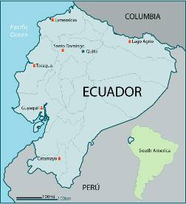
In addition to creating new projects, HFH- Ecuador is actively involved in the local network of foundations who are working to change the Ecuadorian society’s perception of families living in poverty. The network seeks to promote Habitat for Humanity International’s pledge to end poverty housing by promoting the cause of every person’s right to dignified housing. In order to achieve this goal, HFH- Ecuador is involved in changing public policy, creating alliances with governmental bodies and other non-governmental organizations, and encouraging local volunteer projects with corporations and Ecuadorian youth.

HABITAT QUICK FACTS
- Number of housing solutions built to date: 600
- Number of affiliates: 3
- Santo Domingo
- Guayaquil
- Tosagua
  - Year that HFH-Ecuador was founded: 1998
  - Average cost of house in HFH-Ecuador: $7,000 USD

ARRIVING IN ECUADOR
DOCUMENTS
To enter Ecuador you need a passport, valid for at least six months after your stay, and US $25-41.90 in cash to pay the airport tax upon departure from the national airport. Ecuador requires that you also have proof of departure (i.e. return ticket) before they will allow you to enter. Ecuador does not require visas for trips of less than 90 days if you are American, Canadian, or a citizen of most European countries. When you arrive at the airport, you will receive an immigration form that you must fill out before you receive your 90 day entry validation.
We recommend that team leaders make a copy of the first page of each participant’s passport and keep the copies with them at ALL times while the group is in Ecuador. The original passports should be kept in a safe place and each participant should also carry a copy of the first page of their own passport with them at all times.

For information on travel to Ecuador go to the Ecuadorian Embassy website at the following address:
http://www.ecuador.org/tourism.htm

For travel and entry information specific to your country of departure, please visit the following sites:

- U.S. Citizens: Consular Information Sheet, US Department of State:
http://travel.state.gov/travel/cis_pa_tw/cis/cis_1106.html

- United Kingdom Citizen’s: UK Foreign and Commercial Office: http://www.fco.gov.uk/servlet/Front?pagename=OpenMarket%2FXcelerate%2FShowPage&c=Page&cid=1007029390590&a=KCountryAdvice&aid=1013618385866

- Canadian Citizens: Canada Department of Foreign Affairs and International Trade:
http://www.voyage.gc.ca/dest/report-en.asp?country=78000

- Australian Citizens: Australian Department of Foreign Affairs and Trade: http://www.dfat.gov.au/geo/ecuador/index.html

HEALTH REQUIREMENTS
The Center for Disease Control provides tips about how to stay healthy in-country and recommendations for immunizations (www.cdc.gov). We encourage every participant to be up to date on his/her tetanus shot (good for 10 years). It is best to encourage participants to consult a travel clinic and/or their personal physician on which shots are required and which are recommended. Despite these suggestions, Ecuador does not have any vaccine requirements to enter. You should be aware, though, that in some regions disease-transmitting mosquitoes do exist. There are many easy and inexpensive ways to prevent related risks before or during your visit to Ecuador. Please make sure that you send all medical emergency information to your team leader at least 20 days before your trip starts. This should include:
- Full Name
- Emergency contact
- Medications regularly taken
- Allergies of any kind (Food, medication, bees etc.)
- Any recent or chronic serious illness or surgery
- Any specific medical limitations or needs
- Blood type
- Any other medically pertinent information

HFH MINOR POLICY
Minors (applicants under the age of 18) not accompanied by a parent or legal guardian must submit a memorandum of understanding (MOU) in which the guardian and/or institution with which the minor is traveling accepts responsibility. Minors must complete a special waiver that must be notarized. Please ask your team leader to request this form.

AT THE AIRPORT
Each team member should carry the emergency contact information (see Contact Information section) on their person as they are traveling. If, for some reason, a team member misses a flight and will not arrive at the specified time, they must call the team leader AND GV Coordinator to alert them.

Be aware of your luggage at all times and watch out for potential pickpockets. A Habitat employee will welcome you at the airport with a sign that says ‘Habitat’. Do not accept help from strangers. The GV Coordinator will take care of everything for you. The coordinator will take you to your hotel or to the affiliate office.

Should your luggage be lost, please contact your airline representative; the Habitat coordinator will then help you arrange delivery or pick up.

MONEY
The currency in Ecuador is the US dollar. Quito and Guayaquil have ATM machines and banks where you may exchange traveler’s checks. Many banks are reluctant to change traveler’s checks so you may wish to bring cash in small bills ($10s and $20s) as well as credit and debit cards. It is a good idea to inform your bank that you will be traveling to Ecuador so they will not question any debit or credit card purchases made in-country. The coordinator will inform you of the availability of services at your affiliate.

THE WEATHER IN ECUADOR
Due to geographic differences, Ecuador’s weather varies tremendously throughout its regions. The Pacific coast has a rainy season between December and May and a dry season from June to November. The temperature oscillates between 73º F and 79º F. The Highlands, on the other hand, has a rainy, cold climate from November to April and a dry one from May to October. The temperature here is between 55º F and 64º F. In the Amazon, the climate is rainy and humid between January and September, with temperatures between 73º F and 97º F, and dry between October and December. Go to the following website to find weather reports by city. Once there, simply click on the city in which you are interested: http://www.wunderground.com/global/EQ.html

TIME ZONES
For information regarding the time in Ecuador in relation to your own time zone, you might check out the following websites: “www.thetimenow.com” or “www.worldtimeserver.com”.

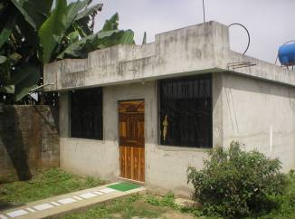

THE HOUSE GOES UP
CONSTUCTION STYLE
HFH-Ecuador builds homes with interior floor space between 49-54 square meters (527-581 square feet). They are simple and economical while being safe and durable. The materials used are of the best quality and are built to resist earthquakes. The houses are made of cinder blocks, rebar and cement. Each house has its own septic tank system or is connected to a municipal grid. There are typically 2 bedrooms, a kitchen, living/dining room and a bathroom.

QUALIFYING FOR A HABITAT HOUSE
Each family must have their own land. They must also have a “real need” for a house and fall within an income bracket determined by each affiliate. Each Habitat family must also include children. Ability to participate in the construction process, or “sweat equity”, is a non-negotiable factor in the selection process. However, if the homeowner works, or is physically unable to build, a family member or friend may substitute for them. Ultimately, the homeowner is responsible for their construction hours.
DURATION OF BUILDING PROCESS
Usually it takes 5-7 weeks to build a Habitat home. To put the “sweat equity” (Habitat families contributing manual labor to the construction of their home and the homes of neighbors) principle into action, 2-3 families form a work team and rotate the construction work until all the homes are built. All the families then receive the keys to their new homes at the same time.
COST OF HOMES
The average cost of a Habitat house in Ecuador is $7,000, although the price can vary depending on many factors such as cost inflation of materials, geographical situations of the families’ land, or other circumstances. The family usually has a monthly payment of $60-90 over a 6 year period.
YOUR JOB ON THE SITE
You will need to be motivated to work together with the families during the construction process. Typically there will be two contractors on site to help you and guide you along.
Your work-team can expect to perform a variety of jobs, such as: pouring the foundation, cutting or tying rebar and wire, or forming the rebar structure laying bricks, mixing cement by hand or digging the septic tank and foundation.
Some work on-site…

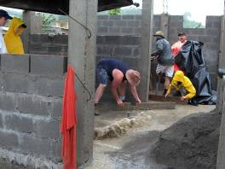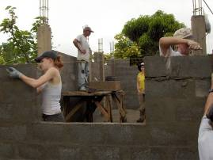

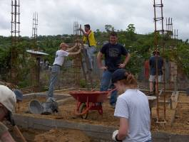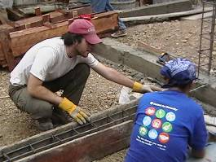

YOUR STAY IN ECUADOR

GREETINGS
It is important to greet people when entering a house, restaurant or any other establishment. Usually you will offer your right hand and sometimes you will exchange a kiss on your right cheek (This is more common in larger cities, and is not done when one man greets another).

SECURITY
You don´t need to be afraid in Ecuador, but you should always be alert. Don´t leave belongings unattended. Do not walk around town with your passport. Keep it in a safe place and make 2 photocopies, one to keep with you and one for the team leader. If you need to separate from the group, take at least one other person with you. Do not stay out late at night. Do not wear expensive-looking jewelry or show off any expensive items. If you do consume alcohol, make sure it is in moderation. If you go to the beach, don´t swim alone, in the dark or after consuming alcohol.

MEAL TIME
Usually breakfast and dinner will be served in the hotel or a nearby local restaurant. Lunch will be eaten on the worksite and will either be prepared by the hotel to take with you in the a.m., or delivered by a local restaurant.
We will be providing purified water at your work site. Be sure not to drink water from the faucet or brush your teeth with it. Always drink bottled or purified water.
Do not eat raw vegetables or unpeeled fruit and avoid eating food from street vendors.
If you get diarrhea please inform the coordinator immediately. Usually the problem resolves itself in 1-2 days. Wash your hands frequently, rest as necessary and drink a lot of liquids.

- Breakfast: To gear up for the day, you will enjoy a wonderful typical Ecuadorian breakfast and coffee.
- Lunch: a typical meal is served with a soup as starter and a dish of rice, vegetables, plantains and beef or chicken.
- Dinner: To be a “real Ecuadorian” you must have your soup, rice, plantains, salad and (chicken, fish or beef) for dinner. The menu will vary nightly.
- Snacks on site: We will provide drinking water and fruit for a quick break and energy boost both in the morning and afternoon.
- Drinking Water: The water in Ecuador is NOT potable; do not drink water that is not purified. Most hotels have a water purification system.

(Note: If anyone has special dietary needs, please let us know ahead of time. Please remember that vegetarianism is not the norm in Ecuador and does not mean the same thing for everyone, but simple requests for no meat, as well as chicken, fish, eggs or dairy products… or not, can easily be honored. Don’t expect veggie lasagna or soymilk, but you will enjoy lots of salad, fruit, eggs, cheese, rice and beans.)

YOUR BED WHILE IN ECUADOR
Habitat for Humanity-Ecuador will determine the best lodging option for your group and inform the leader after giving thought to the characteristics of the group and the proximity to the construction site. Work teams stay in hotels or retreat centers that are simple, safe, and clean. We place 2-3 people per room and, depending on the location, there will be individual or double beds. If a team-member needs a private room, there will be an additional charge per day (please inform your team leader if this pertains to anyone on your team). Usually the rooms have a private bathroom, but sometimes they are shared; we will let you know. Unless we notify you, your hotel will have hot water.
*Your team does NOT have to bring bedding or towels. Please note that the plumbing in most countries in South America cannot support toilet paper of any kind. For this reason, small cans are placed next to the toilet. Please do not throw ANY paper in the toilets or they will most likely become clogged.
TRANSPORTATION
The GV coordinator in Ecuador will arrange ONE pick-up from the airport closest to the work site and be there to welcome you. If you need to spend the night in Quito before taking another flight, we will help you arrange transportation, and even welcome you, but the cost of this transportation is not included in the 35$ per day. We will also arrange daily transportation to the worksite which will either be a private bus, the public bus or the affiliate auto. Sometimes you may be close enough to walk to the site. If you do not return to the same airport, or take a different route to get there (many groups choose to do this due to R&R), you will receive credit for the same amount as the cost of the pick-up.

WHAT TO BRING

- Old work clothes are especially recommended. (FYI…after building, you may leave your old clothes for Habitat to sell at a garage sale for a low symbolic price to Habitat families)
- 1 nice outfit (but not too fancy) if your group wants to go to church, if there is a house dedication, etc…
- LOTS of sunscreen (don’t say we did not warn you about the sun!!)
- Hat
- Simple first aid kit (one will be on the work-site too)
- Work gloves
- Boots or closed-toed shoes with big soles.
- Sunglasses
- Bathing suit
- Camera
- Journal
- Required medicines (pack the prescription along with the medicine for customs)
- Flashlight
- Personal items
- Rain jacket or umbrella
- Warm sweater ( it usually gets cooler at night)
- Mosquito repellent
- Water bottle
- Electric devices should be 110 volt
- 2 copies of passport and airline tickets
- money for personal expenses
- English/Spanish dictionary
- Snacks you particularly like
- Small Tools to use while on site and can leave with affiliate: hammers, screwdrivers, wire cutters, pliers, extra gloves, etc...
- Bubbles or chalk to play with the children on the worksite

THE FINE PRINT

- There will be NO alcohol allowed on the worksite at any time.

- Please be sure to wear clothing appropriate for the construction site. You may wear shorts, but please do not make them too short. Sleeveless shirts are OK, but please no spaghetti straps. Remember, you will already be the center of attraction in the neighborhood; we do not need unwanted attention that may compromise safety as a result of inappropriate dress. It is mandatory that all workers wear helmets and safety goggles (when applicable) at all times on-site.

- Please help us to continue improving our GV program by filling out and turning back in the simple and quick evaluation form which we will provide. Please, do not wait until the end of your trip to inform the GV Coordinator of any problems you experience during your stay.

In order to provide you with a rewarding trip, please do not hesitate to notify your team leader and the GV coordinator if anything goes wrong. Don’t wait until you fill out the evaluation at the end of your stay to inform us of problems.

CONTACT INFORMATION

GV Area Coordinator: Stephanie Banas
(South America, Caribbean)
1-800-422-4828 ext. 2878 (within the (US)
229-924-6935 ext. 2878 (outside the (US)
847-494-6569 cell phone
208-275-3202 fax
E-mail: sbanas@habitat.org
Web: www.Habitat.org/gv

Stephanie Banas will communicate with the National GV Coordinator and confirm the arrival of the brigade. She will mail all necessary information to the brigade Leader.

National Host Coordinator: Carley Therese Simpson de Dávila
(Ecuador) E-mail: brigadas@hphecuador.org
(593-2) 243 3358 telephone
(593-9) 792 7319 cell phone

Hábitat para la Humanidad Ecuador:
Mailing address

Hábitat para la Humanidad
Inglaterra E3-235 entre Amazonas y Republica
3er piso
Quito, Ecuador
América Sur
T: 593.2.243.3358
E-mail: brigadas@hphecuador.org
Website: www.hphecuador.org

A few words…

“This day is the most important of my life. One of my dreams has become reality, the dream to have my own house in which to live modestly and peacefully with my family”
    - Irene Laino, house owner at the Esmeraldas affiliate.

"Our dream, since I married Tanya, was to work and, as the fruit of our labor, one day to have our own house.”

    - Carlos Bravo, house owner at the Catamayo affiliate

“We all left with a great smile, and at the end of the day, we returned tired, but with a bigger smile, committed to the same goal: to better society and ourselves.”

    - Bito, a volunteer with Habitat Ecuador

Let’s work together, let’s contribute, let’s get involved, let’s change the world one house at a time!!!!

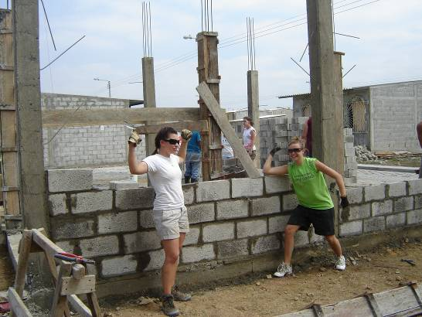

Lonely Planet Website: “Introduction”: http://www.lonelyplanet.com/destinations/south_america/ecuador_and_the_galapagos_islands/index.htm
The World Bank: Poverty Profile: “http://poverty.worldbank.org/library/view/8644/”
http://www.vivecuador.com/html2/eng/climate.htm

